### User Group Settings

All users belong to the Master Users Group by default. HIE Administrators should remain in the Master Users Group. User Group Administrators and all other users may be reassigned to a Child User Group, depending on affiliation.

Click **Change User Group** to add the user to a Child User Group beneath the Master Users Group.

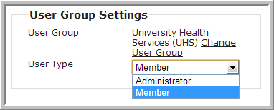

Next, click on arrow to choose the appropriate User Group. If the correct User Group does not yet exist, see the “Add Child User Group” section.

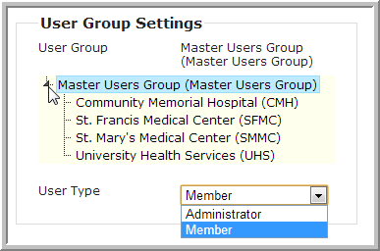

Then, assign a User Type. All non-administrators have User Type of **Member** by default. For users who will have an Administrator or User Group Administrator role**,** select **Administrator**.